Homework lesson 17.

1. In Google Docs, create 5 test cases for functional testing of the <https://www.carsforsale.com> website (5 top priority tests).

**Test Case**

1. Registration functionality

**Preconditions**

Computer turned on

Access to internet

Browser installed

Site <https://www.carsforsale.com> is opened

| **Steps** | **Expected result** |
| --- | --- |
| 1. Click on Sign in button on the upper right corner |  |
| 2. Click on the Individual button | A pop up window appeared |
| 3. Click on the Sign in with Google button | A pop up window appeared |
| 4. Choose [mihaela.baculea@gmail.com](mailto:mihaela.baculea@gmail.com) account |  |
| 5. Click Confirm | Registration successfully |

**Test Case**

2. Navigation functionality

**Preconditions**

Computer turned on

Access to internet

Browser installed

Site <https://www.carsforsale.com> is opened

| **Steps** | **Expected result** |
| --- | --- |
| 1. On the top menu bar click on Cars for Sale button | A new page opens |
| 2. Scroll down to Top Used Car Makes category |  |
| 3. Click on BMW | A new page opens |
| 4. Click on the Cars for Sale logo located on the upper left corner | The home page opens |

**Test Case**

2. Navigation functionality

**Preconditions**

Computer turned on

Access to internet

Browser installed

Site <https://www.carsforsale.com> is opened

| **Steps** | **Expected result** |
| --- | --- |
| 1. On the top menu bar click on Cars for Sale button | A new page opens |
| 2. Scroll down to Top Used Car Makes category |  |
| 3. Click on BMW | A new page opens |
| 4. Click on 2021 BMW X3 | A new product details page opens |

**Test Case**

3. Contact seller

**Preconditions**

Computer turned on

Access to internet

Browser installed

Site <https://www.carsforsale.com> is opened

| **Steps** | **Expected result** |
| --- | --- |
| 1. Scroll down to the footer |  |
| 2. Click on Contact us button | A new page opens |
| 3. Fill in the email field with the invalid address [mihaela.baculea@ail.com](mailto:mihaela.baculea@gmail.com) |  |
| 4. Fill in the Comments field with “Test message” text |  |
| 5. Click Send | An error message “Please insert a valid email address” appears |

**Test Case**

4. Filtering functionality

**Preconditions**

Computer turned on

Access to internet

Browser installed

Site <https://www.carsforsale.com> is opened

| **Steps** | **Expected result** |
| --- | --- |
| 1. At All makes selector, select BMW |  |
| 2. At All models selector, select 7 Series |  |
| 3. At Min price selector, select 5000$ |  |
| 4. At Max price selector, select 20000$ |  |
| 5. Click Find yours | A new page with products according to selected criteria opens |

**Test Case**

5. Like functionality

**Preconditions**

Computer turned on

Access to internet

Browser installed

Site <https://www.carsforsale.com> is opened

| **Steps** | **Expected result** |
| --- | --- |
| 1. Scroll down to Newly listed cars for sale category |  |
| 2. On the 1st car 2012 Jeep Grand Cherokee click on heart icon | Heart icon colors red |
| 3. Scroll up to top menu bar |  |
| 4. Click on Favorites button | A new page with 2012 Jeep Grand Cherokee displayed opens |

2. Create a document and describe in it the bugs you found. The description can be of any format, but must include screenshots. Add the document to LMS.

1. List users - when using GET to receive the list of users. It returns only 6 users located on the 1st page and not all the users form pages 1 and 2



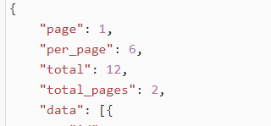

1. Single user

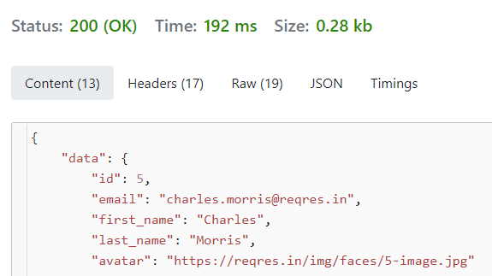

1. Create - after creating a new user id and using GET for showing the id created it returns 404 Not found

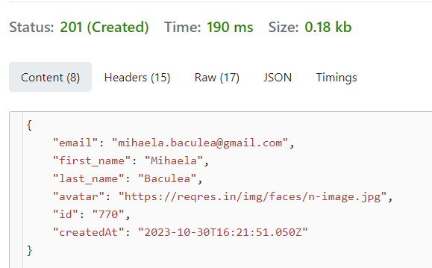



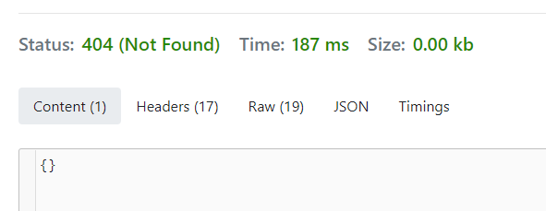

1. Patch

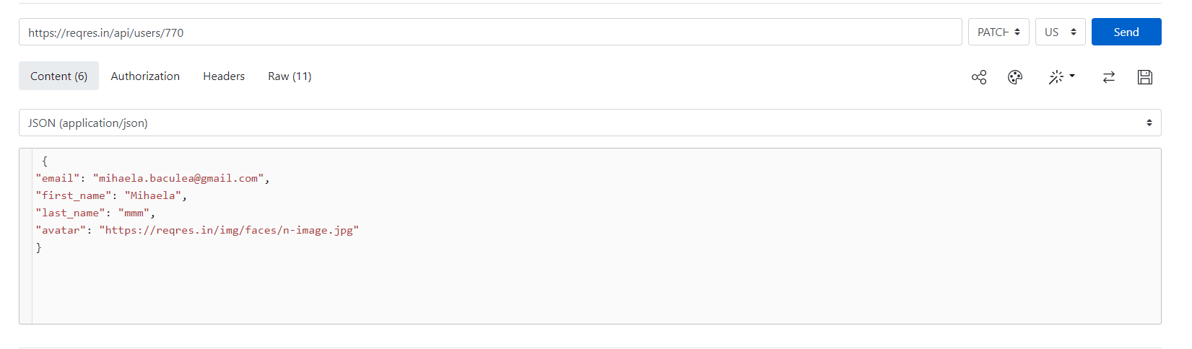

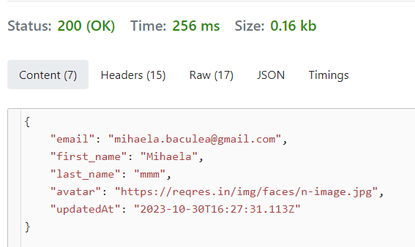

1. Delete

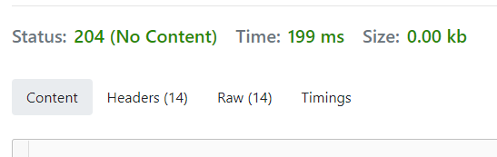

1. Register

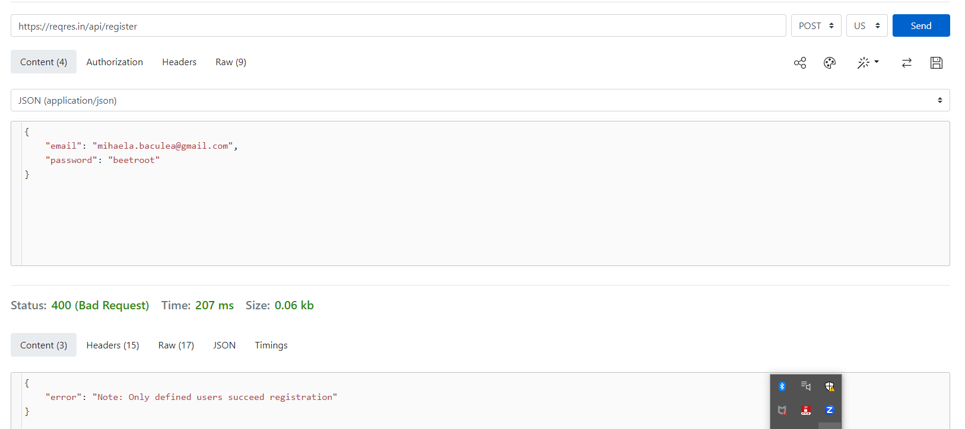

1. Login

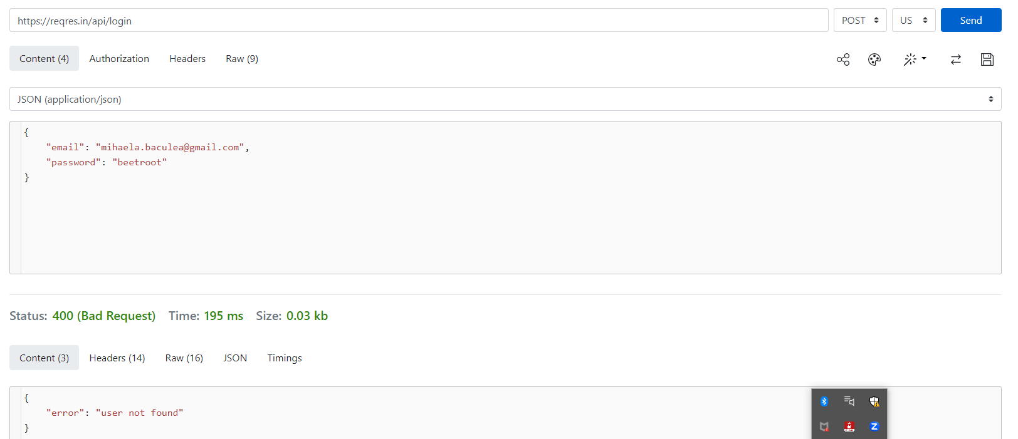

3.

GET

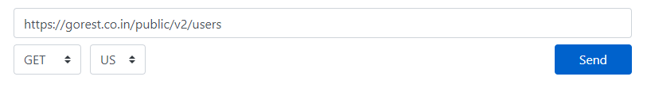



CREATE

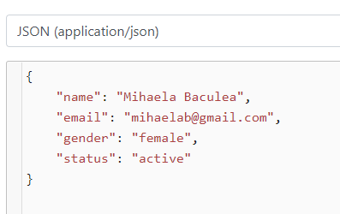



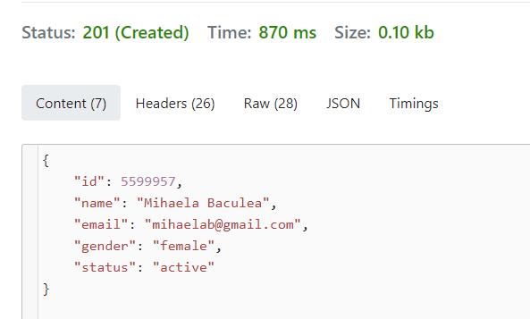



PATCH

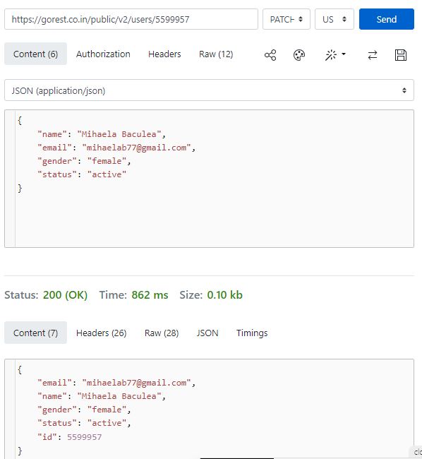

DELETE

